RIHAM AHAMED ABDUL RAHEEM

HND COMPUTING IDM

SYSTEM ANALYSIS & DESIGN

Induvidiual report

Contents

**SYSTEM DEVELOPMENT LIFE CYCLE** 1

What is SDLC? 1

**Planning** 2

**Analysis** 2

**Design** 2

**Implementation** 3

**Maintenance** 3

**TRADITIONAL & AGILE APPROACHES** 4

What is traditional project management? 4

What is agile project management? 5

Traditional or Agile? 6

**LIFECYCLE MODALS THAT CAN BE USED AT IFRB** 7

Waterfall 7

Six sigma 8

Scrum 9

Kanban 10

**WHAT IS THE BEST APPROACH IFRB CAN FOLLOW?** 11

References 12

**List of figure**

Figure 1: System development life cycle 1

Figure 2: Traditional & agile approaches 4

Figure 3: Waterfall model 7

Figure 4:Waterfall model Advantages & Disadvantages 8

Figure 5: Scrum development process 9

**List of Table**

Table 1: Agile vs Traditional 6

Table 2: Six sigma model advantages & disadvantages 8

Table 3: Scrum model advantages & disadvantages 10

Table 4: Kanban model advantages & disadvantages 10

# **SYSTEM DEVELOPMENT LIFE CYCLE**

## What is SDLC?

Figure 1: System development life cycle

The system development life cycle is a set of procedures that developers perform during the development of a new system. The software development life cycle is important because it regulates the amount of money and effort that goes into a particular organization. It may not seem important to an individual, but overall, when engaging in a business, everything is measured by the amount of profit it makes, which is very important.

By following the SDLC, you make sure that you do not put too much or too little effort into a particular system, and that you do not go back on your way to start all over again. Development. Your existing settlement needs are not fully met. (Tutorialspoint, 2021)

There are 5 main steps in SDLC:

1. Planning
2. Analysis
3. Design
4. Implementation
5. Maintenance

Of course, this is a topic, there may be more steps than this in the actual SDLC, but never less. In fact, any good developer will accidentally go through these 5 key steps and lead to a product with good clean code and timely delivery.

### **Planning**

The planning stage establishes project objectives and prepares a high-level plan for the imagined project. Planning is, by definition, a fundamental and important organizational stage. The three main activities involved in the planning phase are as follows:

* Identification of the system for development
* Feasibility assessment
* Creation of project plan

### **Analysis**

This is the level at which all companies try their best, but do not go deep enough. This is another research step similar to a potential study, but this activity focuses more on the problems of the existing system.

Computer researchers will try to use fact-finding techniques such as:

* Questionnaires
* Interviews
* Observation
* Examining log files
* Consulting management

Then, with these fact-finding techniques, during the analysis phase, the researchers very clearly identify all the existing problems and document them accordingly.

### **Design**

This stage is a much more complex phase than the previous one and I think it is more important in any SDLC. The results of this phase will be used by the inventors and other staff to create a system. Therefore, any warnings, trades, pros, and cons in this design will be reflected in the final product.

IFRP should do everything it can to dig deeper to understand the best, cleanest, most flexible, and scalable design. This not only helps to ensure that the final product is correct, but also to deliver something that can be produced within the allotted time for the money provided.

In the design stage, you’re primarily concerned with things like:

1. Input/output
2. 3.UI / UX
3. Backup and fail-safe recovery procedures
4. Security
5. Licenses
6. Standards
7. Test plans
8. Data storage

### **Implementation**

This phase is very easy to do as the previous grids were done correctly. If for any reason the previous stages were not done correctly, you will waste a lot of time and most of the money at this stage, resulting in poor resolution and dissatisfied customers, I think that is what IFRP is dealing with now.

At this point, you give the meat to the assembled skeleton during the design phase. This means you:

1. Be involved in the development
2. Review the code
3. Conduct strategic meetings
4. Check your codebase for errors
5. Ensure that your implementation **does not in any way or form go beyond the design**.
6. Create user and system documents.
7. Use your solution in the intended environment to test compatibility.
8. Conduct post-implementation reviews.

### **Maintenance**

This is the final stage of the SDLC, which is where you go and clean the loose edges of the implementation. At this point, you should have a working solution that covers at least 75% of all user and system needs, works without bugs/errors breaking the application, and can deliver it to your customer.

Often, most companies try to change or rewrite the details of the implementation at this point. **Do not do this**. This may break your existing solution.

After this point, you can restart the entire cycle anew, depending on the needs of your customers.

(Tutorialspoint, 2021)

# **TRADITIONAL & AGILE APPROACHES**

## What is traditional project management?

Figure 2: Traditional & agile approaches

Traditional project management (TPM) is a standardized process for projects that must be managed consistently (one after the other). The main stages you will see in many such approaches.

1. Initiation
2. Planning
3. Execution
4. Monitoring
5. Completion

Traditional project management emphasizes that your processes are linear, documented, planned, and properly prioritized. The TPM method revolves around the concept that time and budget are variable, but requirements are fixed. As a result of this concept, proponents of the TPM approach face time and budget constraints. For each step, there is a standard officially defined by the company PMBOK, which all project managers follow word for word. (Tutorialspoint, 2021)

Despite the flaws in this approach, there are some notable benefits one can observe in TPM:

1. Extremely clear objectives
2. Highly controllable procedures
3. Concise documentation
4. Higher accountability within the staff

## What is agile project management?

This approach is now the best known and most widely used method in the world. All companies have recognized the benefits of agile development, so it has become a priority for all DevOps employees to prioritize their learning journey.

So, what makes agile project management so revolutionary? It is teamwork. In essence, agile project management relies heavily on combining efforts within a team. The collaboration and scheduling of difficult tasks and the great flexibility to respond to change as quickly as possible are what have made agile project management triumph over traditional project management.

The 4 main golden rules in agile project management are:

1. Higher focus on each individual than the processes or the tools involved
2. Development is more important than documentation
3. collaboration with clients is more important than negotiating with them
4. The process must be able to quickly respond to change than following an absolute plan

Now with these 4 rules, it must become obvious what benefits there are in following agile project management:

1. Higher flexibility in terms of prioritization than the traditional approach
2. Much more predictable and earlier delivery
3. The budget, project scheduling, and timeline is more predictable
4. Quality is much more improved
5. Higher transparency due to high flexibility
6. Employees feel more involved leading to productive hours of work

Every agile approach has one thing in common. Tasks are iterative. Each task in a project is broken down into short "sprints" that take less time. Unlike TPM, planning and prioritization are not crucial, so agility is more flexible in terms of changes. (Tutorialspoint, 2021)

## Traditional or Agile?

Go through the following table, each approach is better in certain characteristics and aren't as good in some

Table 1: Agile vs Traditional

|  |  |  |
| --- | --- | --- |
| **Characteristics** | **Agile** | **Traditional** |
| Organizational Structure | Iterative | Linear |
| Scale | Small to medium | Large |
| Development model | Evolutionary | Cycle |
| Preference | Adaptation | Anticipation |
| Focus | Product | Process |
| Client involvement | High | Low |
| Testing | Flexible | Sequential |

As you can see from the table above, agile is more beneficial than traditional in most situations, so it is more widely used. While the table says that Agile can only be used for small to medium-sized teams, there are specialized agile approaches designed for large-scale teams, these approaches are not as popular as the traditional ones for large teams.

# **LIFECYCLE MODALS THAT CAN BE USED AT IFRB**

## Waterfall

Figure 3: Waterfall model

This is a traditional project management approach that focuses on being linear and sequential above everything else. This is the oldest known SDLC approach to software development and has many solutions for existing caveats, even if it is the traditional approach.

The waterfall method has the following requirements:

1. Clear documentation
2. Product defining must be stable
3. The technology used cannot be dynamic
4. There are no vague requirements
5. Project must be short

(Tutorialspoint, 2021)

|  |  |
| --- | --- |
| Advantages | Disadvantages |
| Simple and very easy to comprehend | The solution is not bought to a working point till the end |
| Properly stated milestones | Higher risk and uncertainty |
| Clearly defined stages | Bad for OOP based development |
| Processes and the results are very well documented | Cannot respond to change. |

Figure 4:Waterfall model Advantages & Disadvantages

## Six sigma

It is an evolution of a traditional project management model first introduced in 1986 by Motorola engineers. The main focus in this modal is to reduce the number of errors in a process by eliminating what is not working and then eliminating it. As a result, it is now considered obsolete and not used much anymore. (Staff, 2020)

The main requirements in Six Sigma are:

1. Definition of the problems and objectives of the project
2. Measuring different aspects in the current process
3. Analyze data and then find the biggest flaws in the process
4. Determine how the process repeats in the future.

Table : Six sigma model advantages & disadvantages

|  |  |
| --- | --- |
| Advantages | Disadvantages |
| Ideal for small scale projects | More time is spent in development |
| Debugging is as simple as identifying, removal and re-implementing | Unclear as to what’s done |
| Documentation is concise | Repetition might take place |

## Scrum

One of the most well-known agile approaches out there in the industry. It is so famous because it prioritizes the development, delivery, and maintenance of highly complex products through iterative collaboration with the entire team in charge. (Scrum, 2021)

The main requirements of Scrum are:

1. Extreme compromise
2. Openness within team members
3. Respect among team members
4. Focus as a team on difficult tasks
5. 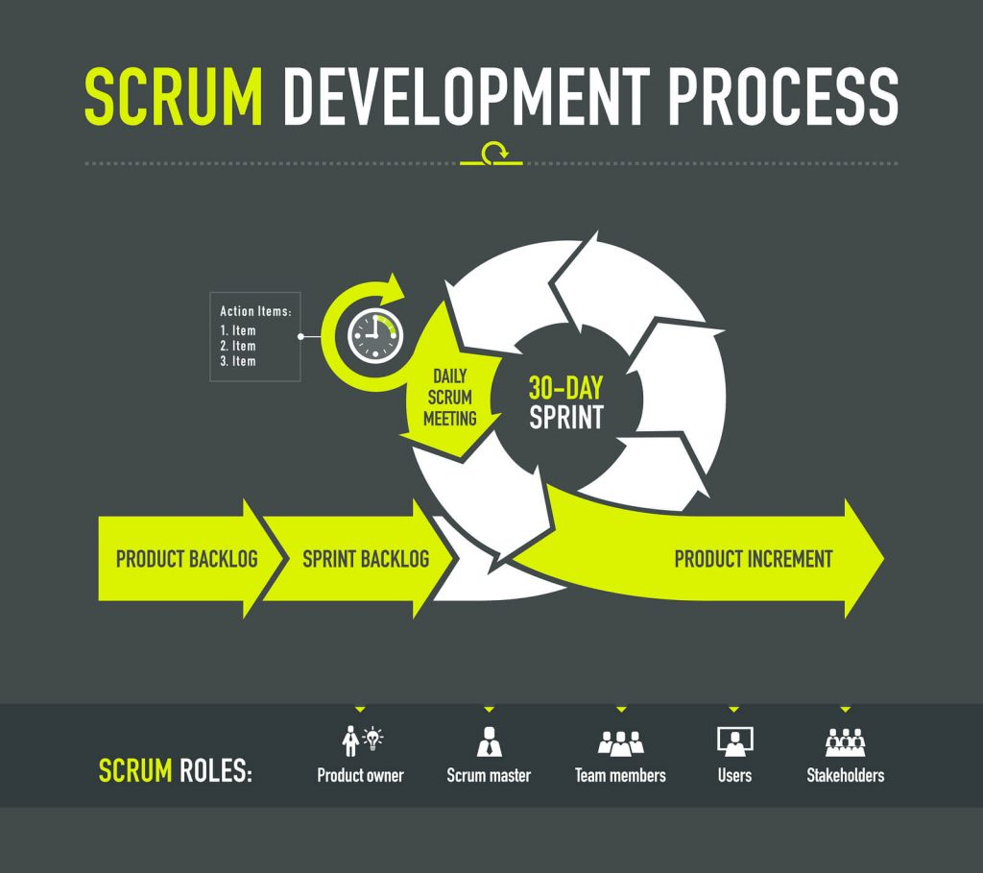Courage to take on difficult tasks as a team.

Figure : Scrum development process

There are what’s called “events” in scrum approaches:

* Sprint: Iteratively time boxing to achieve a goal. The time frame of each sprint can not exceed a month and must be consistent throughout the development process.
* Sprint planning: The whole team must get together to plan the next sprint
* Daily Scrum: Usually a 10 minutes’ time boxed meeting that is held at the same time every day of a sprint to discuss achievements and to layout expectations.
* Sprint review: A casual meeting held at the end of every sprint where the teams present their achievements, feedback and discuss with stakeholders.
* Sprint retrospective: A formal meeting where the team reflects on the finished sprint and then decide how they can improve in their next.

Table : Scrum model advantages & disadvantages

|  |  |
| --- | --- |
| Advantages | Disadvantages |
| Team-focused, everybody enjoys working | Lack of priority to documentation |
| Very efficient in terms of delegating tasks | Less focus on process control and planning |
| Extremely cost-effective | Recommended for teams that are usually small |

## Kanban

Kanban is also another very popular agile approach, similar in many ways to scrum. It was introduced by Toyota in the 1940s. It focuses on being extremely visual with respect to all the processes involved in its development.

The main requirements for Kanban are:

1. Concise visualization
2. Putting limits to work in progress
3. Managing the general flow
4. Feedback loop
5. Collaborative evolution

As I mentioned, Kanban is extremely visual, which is why a drawing of a so-called Kanban board is generally used, in which Kanban cards isolate tasks and Kanban swim lanes for better organization. (Atlassian, 2021)

Table : Kanban model advantages & disadvantages

|  |  |
| --- | --- |
| Advantages | Disadvantages |
| Continuous Integration | Lack of focus on documentation |
| Extremely visual | Specific tools are required to draw visually appealing Kanban boards |
| General sense of comprehension within the team |

# **WHAT IS THE BEST APPROACH IFRB CAN FOLLOW?**

Personally, I say that Scrum is the best approach for which IFRB is best suited. I think the main reason why IFRB teams can't produce quality products on time is due to communication barriers or lack of communication. As such, there should be more focus on individual team members and the workflow of the team as a whole than on processes, tools, and all that. Because IFRB is clearly capable of producing quality content, but not within the time frame.

How will Scrum break the communication barrier? One of the most important and attractive things about scrum is the fact that it prioritizes holding many meetings. During these meetings, individual team members will identify their issues, notify each other of delays, set expectations, clearly identify what to do and what not to do, and prioritize having a general idea of ​​what the job is. He is within the team and generally leads to an efficient team that puts communication first.

With all these factors combined and communication playing a key role within the team, I assume that teams will be more flexible with their clients and will work with clients rather than negotiate with them, eliminating the need to make unnecessary changes or waste time. wasting on changing bits is eliminated. and parts.

In this way, I think the IFRB teams can move forward quickly and deliver quality products in the expected period.

# References

Atlassian, 2021. *Atlassian agile coach.* [Online]   
Available at: https://www.atlassian.com/agile/kanban  
[Accessed 17 June 2021].

Scrum, 2021. *scrum.org.* [Online]   
Available at: https://www.scrum.org/resources/what-is-scrum  
[Accessed 17 June 2021].

Staff, 2020. *Sixsigmadaily.* [Online]   
Available at: https://www.sixsigmadaily.com/what-is-six-sigma/  
[Accessed 17 June 2021].

Tutorialspoint, 2021. *Agile Project Management.* [Online]   
Available at: https://www.tutorialspoint.com/management_concepts/agile_project_management.htm  
[Accessed 17 June 2021].

Tutorialspoint, 2021. *SDLC - Waterfall Model.* [Online]   
Available at: https://www.tutorialspoint.com/sdlc/sdlc_waterfall_model.htm  
[Accessed 17 June 2021].

Tutorialspoint, 2021. *Traditional Project Management.* [Online]   
Available at: https://www.tutorialspoint.com/management_concepts/traditional_project_management.htm  
[Accessed 17 June 2021].

Tutorialspoint, 2021. *tutorialspoint.* [Online]   
Available at: https://www.tutorialspoint.com/sdlc/sdlc_overview.htm  
[Accessed 17 June 2021].